Programming with C++

3

UNIT -1

Concepts of Object Oriented programming: differences between Object Oriented Programming and Structured programing oriented programming, Structure/layout of a C++ program, Data types, identifiers, variables, constants, operators,keywords, control structures & loops.

Overview of C language:
- C language is known as structure oriented language or procedure oriented language
- Employs top-down programming approach where a problem is viewed as a sequence of tasks to be performed.
- All program code of c can be executed in C++ but converse many not be possible
- Function overloading and operator overloading are not possible.
- Local variables can be declared only at the beginning of the block.
- Program controls are through jumps and calls to subroutines.
7.Polymorphism, encapsulation and inheritance are not possible.
For solving the problems, the problem is divided into a number of modules. Each module is a subprogram.
- Data abstraction property is not supported by procedure oriented language.
- Data in procedure oriented language is open and can be accessed by any function.

Overview of C++ language:
- C++ can be considered as an incremental version of c language which consists all programming language constructs with newly added features of object oriented programming.
- c++ is structure(procedure) oriented and object oriented programming language. 3.The file extension of C++ program is “.CPP”
- Function overloading and operator overloading are possible.
- Variables can be declared in inline i.e when required
- In c++ more emphasis is give on data rather than procedures
- Polymorphism, encapsulation and inheritance are possible.
- Data abstraction property is supported by c++.
- Data access is limited. It can be accessed by providing various visibility modes both for data and member functions. there by providing data security by data hiding
- Dymanic binding is supported by C++ 11..It supports all features of c language
- It can be called as an incremental version of c language
Difference Between Procedure Oriented Programming (POP) & Object Oriented Programming (OOP)

 | Procedure Oriented Programming | Object Oriented Programming
1 | program is divided into small parts called functions. | program is divided into parts called objects.
2 | Importance is not given to data but to functions as well as sequence of actions to be done. | Importance is given to the data rather than procedures or functions because it works as a real world.
3 | follows Top Down approach. | OOP follows Bottom Up approach.
4 | It does not have any access specifier. | OOP has access specifiers named Public, Private, Protected, etc.
5 | Data can move freely from function to function in the system. | objects can move and communicate with each other through member functions.

6 | To add new data and function in POP is not so easy. | OOP provides an easy way to add new data and function.
7 | Most function uses Global data for sharing that can be accessed freely from function to function in the system. | In OOP, data can not move easily from function to function,it can be kept public or private so we can control the access of data.
8 | It does not have any proper way for hiding  data so it is less secure. | OOP provides Data Hiding so provides more  security.
9 | Overloading is not possible. | In OOP, overloading is possible in the form of Function Overloading and Operator Overloading.
10 | Example of Procedure Oriented  Programming are : C, VB, FORTRAN, Pascal. | Example of Object Oriented Programming are : C++, JAVA, VB.NET, C#.NET.

Principles( or features) of object oriented programming:
  - Encapsulation
  - Data abstraction
  - Polymorphism
  - Inheritance
  - Dynamic binding
  - Message passing
Encapsulation: Wrapping of data and functions together as a single unit is known as encapsulation. By default data is not accessible to outside world and they are only accessible through the functions which are wrapped in a class. prevention of data direct access by the program is called data hiding or information hiding

Data abstraction :
Abstraction refers to the act of representing essential features without including the back ground details or explanation. Classes use the concept of abstraction and are defined as a list of attributes such as size, weight, cost and functions to operate on these attributes. They encapsulate all essential properties of the object that are to be created. The attributes are called as data members as they hold data and the functions which operate on these data are called as member functions.
Class use the concept of data abstraction so they are called abstract data type (ADT)

Polymorphism: Polymorphism comes from the Greek words “poly” and “morphism”. “poly” means many and “morphism” means form i.e.. many forms. Polymorphism means the ability to take more than one form. For example, an operation have different behavior in different instances. The behavior depends upon the type of the data used in the operation.
Different ways to achieving polymorphism in C++ program:
    - Function overloading 2) Operator overloading #include<iostream>
using namespace std; int main()
{int a=4; a=a<<2;
cout<<”a=”<<a<<endl; return 0;
}
Inheritance: Inheritance is the process by which one object can acquire the properties of another.

Inheritance is the most promising concept of OOP, which helps realize the goal of constructing software from reusable parts, rather than hand coding every system from scratch. Inheritance not only supports reuse across systems, but also directly facilitates extensibility within a system. Inheritance coupled with polymorphism and dynamic binding minimizes the amount of existing code to be modified while enhancing a system.
When the class child, inherits the class parent, the class child is referred to as derived class (sub class) and the class parent as a base class (super class). In this case, the class child has two parts: a derived part and an incremental part. The derived part is inherited from the class parent. The incremental part is the new code written specifically for the class child.

Dynamic binding:
Binding refers to linking of procedure call to the code to be executed in response to the call. Dynamic binding(or late binding) means the code associated with a given procedure call in not known until the time of call at run time.

Message passing:
An object oriented program consists of set of object that communicate with each other.
Objects communicates with each other by sending and receiving information .
A message for an object is a request for execution of a procedure and there fore invoke the function that is called for an object and generates result

Benefits of object oriented programming (OOPs)
- Reusability: In OOP‟ s programs functions and modules that are written by a user can be reused by other users without any modification.
- Inheritance: Through this we can eliminate redundant code and extend the use of existing classes.
- Data Hiding: The programmer can hide the data and functions in a class from other classes. It helps the programmer to
build the secure programs.
➢
Reduced complexity of a problem: The given problem can be viewed as a collection of different objects. Each object is responsible for a specific task. The problem is solved by interfacing the objects. This technique reduces the
complexity of the program design.
➢
Easy to Maintain and Upgrade: OOP makes it easy to maintain and modify existing code as new objects
can be created with small differences to existing ones. Software complexity can be easily managed.
- Message Passing: The technique of message communication between objects makes the interface with external systems easier.
➢
Modifiability: it is easy to make minor changes in the data representation or the procedures in an OO program. Changes inside a class do not affect any other part of a program, since the only
public interface that the external world has to a class is through the use of methods.

BASIC STRUCTURE OF C++ LANGUAGE : The program written in C++ language follows this basic structure. The sequence of sections should be as they are in the basic structure. A C program should have one or more sections but the sequence of sections is to be followed.
- Documentation section
- Linking section
- Definition section
- Global declaration section & class declarations 5.Member function definition
6. Main function
section main()
{
Declaration section Executable section
}

- DOCUMENTATION SECTION : comes first and is used to document the use of logic or reasons in your program. It can be used to write the program's objective, developer and logic details. The documentation is done in C language with /* and */ . Whatever is written between these two are called comments.
- LINKING SECTION : This section tells the compiler to link the certain occurrences of keywords or functions in your program to the header files specified in this section.
e.g. #include<iostream>
using namespace std;
- directive causes the preprocessor to add the contents of the iostream file to the program. It contains declarations
for cout and cin.

➢
cout is a predefined object that represents the standard output stream. The operator << is an
insertion operator, causes the string in double quotes to be displayed on the screen.
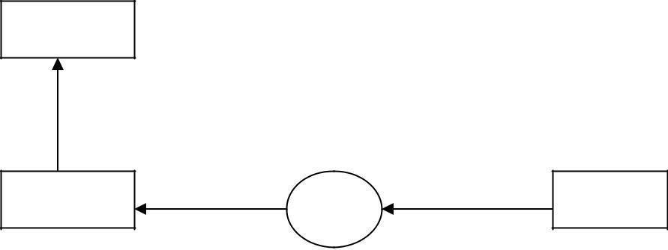
screen

cout << “C++”
Object
Insertion Operator variable

The statement cin>>n; is an input statement and causes the program to wait for the user to type in a number. The number keyed is placed on the variable “n”. The identifier cin is a predefined object in C++ that corresponds to the standard input stream. The operator >> is known as extraction operator. It extracts the value from the keyboard and assigns it to the value variable on its right.

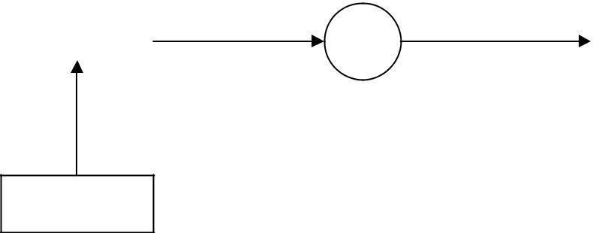
Object Extraction operator variable
>>
Keyboard
45.5
cin
- DEFINITION SECTION : It is used to declare some constants and assign them some value. e.g. #define MAX 25
Here #define is a compiler directive which tells the compiler whenever MAX is found in the program replace it with 25.
- GLOBAL DECLARATION SECTION : Here the variables and class definations which are used through out the program (including main and other functions) are declared so as to make them global(i.e accessible to all parts of program). A CLASS is a collection of data and functions that act or manipulate the data. The data components of a class are called data members and function components of a class are called member functions
A class ca also termed as a blue print or prototype that defines the variable or functions common to all objects of certain kind. It is a user defined data type
e.g.
int i; //this declaration is done outside and before main()

- SUB PROGRAM OR FUNCTION SECTION : This has all the sub programs or the functions which our program needs.

void display()
{
cout<<”C++ is better that C”;
}

SIMPLE „C++‟ PROGRAM:
#include<iostream> using namespace std; void display()
{
cout<<”C++ is better that C”;
}
int main()
{
display() return 0;
}

- MAIN FUNCTION SECTION : It tells the compiler where to start the execution from main()
{
point from execution starts
}
main function has two sections
  - declaration section : In this the variables and their data types are declared.
  - Executable section or instruction section : This has the part of program which actually performs the task we need.
namespace:
namespace is used to define a scope that could hold global identifiers. ex:-namespace scope for c++ standard library.
A classes ,functions and templates are declared within the namespace named std using namespace std;-->directive can be used.

user defined name space:
syntax for defining name space is
namespace namespace_name
{
//declarations of variables.functions,classes etc...
}
ex: #include<iostream> using namespace std; namespace sample
{`
int m;
void display(int n)

{
cout<<"in namespace N="<<n<<endl;
}
}

using namespace sample; int main()
{
int a=5; m=100;
display(200);
cout<<"M in sample name space:"<<sample::m; return 0;}
#include<iostream>
This directive causes the preprocessor to add content of iostream file to the program. some old versions of C++ used iostream.h .if complier does not support ANSI (american nation standard institute) C++ then use header file iostream.h

DATA TYPES:
A data type is used to indicate the type of data value stored in a variable. All C compilers support a variety of data types. This variety of data types allows the programmer to select the type appropriate to the needs of the application as well as the machine. ANSI C supports the following classes of data types: 1.Primary (fundamental) data types.

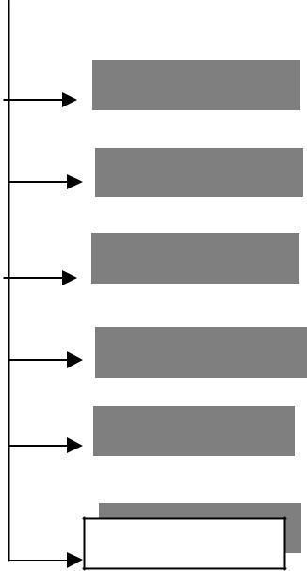
- Derived data types.
- User-defined data types C++ data types

Primary data types
Derived data types
User defined data types

Structure Union Class
Enumeration
typedef
int

char
Array Pointer Reference
float
double
bool

void

Primary data types:
  - integer data type 2.character data type 3.float point data type 4.Boolean data type 5.void data type

integer data type:-
This data type is used to store whole numbers. These numbers do not contain the decimal part. The size of the integer depends upon the world length of a machine (16-bit or 32-bit). On a 16-bit machine, the range of integer values is - 32,768 to +32,767.integer variables are declared by keyword int. C provides control over range of integer values and storage space occupied by these values through the data types: short int, int, long int in both signed and unsigned forms.

Signed integers: (16-bit machine):
A signed integer uses 1 bit for sign and 15 bits for the magnitude of the number
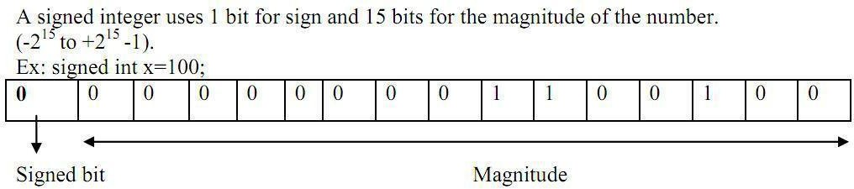
MSB(most significant bit)
=

100(10)

00000000001100100(2)

Representation of negative number :
-100(10)=1111111110011100(2)

15 14 13 12 11 10 9 8 7 -1*2 +1*2 +1*2 +1*2 +1*2 +1*2 +1*2 +1*2

+1*2 +
6 5 4 3 2 1 0

0*2 +0*2 +1*2 +1*2 +1*2 +0*2 +0*2

= -32768+16384+8192+4096+2048+1024+512+256+128+0+0+26+8+4+0+0 =-
100(10)
NOTE: Signed bit (MSB BIT): 0 represents positive integer, 1 represents negative numbers

Unsigned integers: Unsigned integers use all 16 bits to store the magnitude. Stores numbers does not have any sign & Size qualifier and range of integer data type on a 16-bit and machine are shown in the table:

DATA TYPE | MEMORY REQUIRED  OR STORAGE SIZE IN BYTES |  | RANGE
 | TURBO C  ( 16 BIT) | GCC/ COMPILERS  IN LINUX  (32 BIT) | TURBO C  ( 16 BIT) | GCC  (32 BIT)
short int or  signed short int | 2 | 2 | -32768  To  153276715  (-2 to +2 -1) | -32768  To  153276715  (-2 to +2 -1)
short int  or  signed short int | 2 | 2 | 0 to 65535  (0 to +2 -1) | 0 to 65535  (0 to +2 -1)
signed int  or int | 2 | 4 | -32768  To  153276715  (-2 to +2 -1) | -2,147,843,648  to 2,13417,8433,6147  (-2 to +2 -1)
unsigned int | 2 | 4 | 0 to 6515635  (0 to +2 -1) | 0 to 4,2943,2967,295  (0 to2 -1 )
long int  or signed long int | 4 | 4 | -2,147,843,648  to  2,147,843,647  31 31  (-2 to +2 -1) | -2,147,843,648  to  2,147,843,647  31 31  (-2 to +2 -1)
unsigned long int | 4 | 4 | 0 to 4,23942,967,295  (0 to2 -1 ) | 0 to 4,2943,2967,295  (0 to2 -1 )
long long int |  |  |  | -9223372036854775808  To 9223372036854775807  63 63  (-2 to +2 -1)
or  signed long long | Not supported | 8 | --------
int

Character data type: (char)
A single character can be defined as a character data type. Character data type occupies one byte of memory for storage of character. The qualifiers signed or unsigned can be applied on char data type. char is the key word used for declaring variables
size and range of character data type on 16 bit or 32 bit machine can be shown below

Data type | MEMORY REQUIRED  OR STORAGE SIZE (in bytes) | RANGE
char or signed char | 1 | 7  -128 to 127(-2 7 to 2 -1)
Unsigned signed char | 1 | 0 to 256 (0 to 2 -1)

Floating Point Types:

Floating point number represents a real number with 6 digits precision occupies 4 bytes of memory. Floating point variables are declared by the keyword float.
Double floating point data type occupies 8 bytes of memory giving 14 digits of precision. These are also known as double precision numbers. Variables are declared by keyword double
long double refers to a floating point data type that is often more precise than double precision.

Type | Keyword
Boolean | bool
Character | char
Integer | int
Floating point | float
Double floating point | double
Valueless | void
Wide character | wchar_t
Several of the basic types can be modified using one or more of these type modifiers −
- signed
- unsigned
- short
- long
The following table shows the variable type, how much memory it takes to store the value in memory, and what is maximum and minimum value which can be stored in such type of variables.
Type | Typical Bit Width | Typical Range
char | 1byte | -127 to 127 or 0 to 255
unsigned char | 1byte | 0 to 255
signed char | 1byte | -127 to 127
int | 4bytes | -2147483648 to 2147483647
unsigned int | 4bytes | 0 to 4294967295
signed int | 4bytes | -2147483648 to 2147483647
short int | 2bytes | -32768 to 32767
unsigned short int | 2bytes | 0 to 65,535
signed short int | 2bytes | -32768 to 32767
long int | 8bytes | -9223372036854775808 to 9223372036854775807
signed long int | 8bytes | same as long int
unsigned long int | 8bytes | 0 to 18446744073709551615
long long int | 8bytes | -(2^63) to (2^63)-1
unsigned long long int | 8bytes | 0 to 18,446,744,073,709,551,615
float | 4bytes
double | 8bytes
long double | 12bytes
wchar_t | 2 or 4 bytes | 1 wide character
The size of variables might be different from those shown in the above table, depending on the compiler and the computer you are using.
Following is the example, which will produce correct size of various data types on your computer.
Live Demo
#include <iostream>
using namespace std;

int main() {
cout << "Size of char : " << sizeof(char) << endl;
cout << "Size of int : " << sizeof(int) << endl;
cout << "Size of short int : " << sizeof(short int) << endl;
cout << "Size of long int : " << sizeof(long int) << endl;
cout << "Size of float : " << sizeof(float) << endl;
cout << "Size of double : " << sizeof(double) << endl;
cout << "Size of wchar_t : " << sizeof(wchar_t) << endl;

return 0;
}

Boolean or logical data type is a data type, having two values (usually denoted true and false), intended to represent the truth values of logic and Boolean algebra. It is named after George Boole, who first defined an algebraic system of logic in the mid 19th century. The Boolean data type is the primary result of conditional statements, which allow different actions and change control flow depending on whether a programmer-specified Boolean condition evaluates to true or false.
C99 added a Boolean (true/false) type which is defined in the <stdbool.h> header Boolean variable is defined by kkey word bool; Ex:

bool b;
where b is a variable which can store true(1) of false (0)

Void type
The void type has no values. This is usually used to specify the return type of functions. The type of the function said to be void when it does not return any value to the calling function. This is also used for declaring general purpose pointer called void pointer.
Derived data types.
Derived datatypes are Arrays , pointer and references are examples for derived data types.
User-defined data types:
they The data types defined by the user are known as the user-defined data types. They are structure,union,class and enumeration
C++ Tokens
IDENTIFIERS: Identifiers are the names given to various program elements such as variables, functions and arrays. These are user defined names consisting of sequence of letters and digits.
Rules for declaring identifiers:
- The first character must be an alphabet or underscore.
- It must consist of only letters, digits and underscore.
- Identifiers may have any length but only first 31 characters are significant.
- It must not contain white space or blank space.
- We should not use keywords as identifiers.
- Upper and lower case letters are different.
Example: ab Ab aB AB are treated differently

Examples of valid identifiers:
a, x, n, num, SUM, fact, grand_total, sum_of_digits, sum1
Examples of Invalid identifiers: $amount, ³num´, grand-total, sum of digits, 4num.
$amount : Special character is not permitted grand-total : hyphen is not permitted.
sum of digits : blank spaces between the words are not allowed.
4num : should not start with a number (first character must be a letter or underscore
Note: Some compilers of C recognize only the first 8 characters only; because of this they are unable to distinguish identifiers with the words of length more than eight characters.
Variables:A named memory location is called variable.
OR
It is an identifier used to store the value of particular data type in the memory.
Since variable name is identifier we use following rules which are same as of identifier

Rules for declaring Variables names:
- The first character must be an alphabet or underscore.
- It must consist of only letters, digits and underscore.
- Identifiers may have any length but only first 31 characters are significant.
- It must not contain white space or blank space.
- We should not use keywords as identifiers.
- Upper and lower case letters are different.
- Variable names must be unique in the given scope
Ex:int a,b,a;//is in valid
Int a,b;//is valid

Variable declaration: The declaration of variable gives the name for memory location and its size and specifies the range of value that can be stored in that location.
Syntax:
Data type variable name;
Ex: | a | 10 | 2000
int a=10;  float x=2.3; | x |  | 2.300000 | 5000

KEYWORDS :
There are certain words, called keywords (reserved words) that have a predefined meaning in
„C++‟ language. These keywords are only to be used for their intended purpose and not as identifiers.
The following table shows the standard „C++‟ keywords
auto | break | case | char | const | continue
default | do | double | else | enum | extern
float | for | goto | if | int | long
register | return | short | signed | sizeof | static
struct | switch | typedef | union | unsigned | void
volatile | while | class | friend | new | delete
this | public | private | protected | inline | try
throw | catch | template

CONSTANTS:
Constants refer to values that do not change during the execution of a program.
Constants can be divided into two major categories:
- Primary constants:
- Numeric constants
  - Integer constants.
    - Floating-point (real)
constants. b)Character constants
  - Single character constants
  - String constants
- Secondary constants:
  - Enumeration constants.
  - Symbolic constants.
  - Arrays, unions, etc.
Rules for declaring constants:
1.Commas and blank spaces are not permitted within the constant. 2.The constant can be preceded by minus (-) signed if required.
3.The value of a constant must be within its minimum bounds of its specified data type. Integer constants: An integer constant is an integer-valued number. It consists of sequence of digits. Integer constants can be written in three different number systems:
1.Decimal integer (base 10). 2.Octal integer (base 8).
- Hexadecimal (base 16).

Decimal integer constant: It consists of set of digits, 0 to 9.
Valid declaration: 0, 124, -56, + 67, 4567 etc.
Invalid declaration: $245, 2.34, 34 345, 075. 23,345,00. it is also an invalid declaration.
Note: Embedded spaces, commas, characters, special symbols are not allowed between digits
➢
They can be preceded by an optional + or ± sign.

Octal integer: It consists of set of digits, 0 to 7. Ex: 037, 0, 0765, 05557 etc. (valid representation) It is a sequence of digits preceded by 0.
Ex: Invalid representations
0394: digit 9 is not permitted (digits 0 to 7 only)
235: does not begin with 0. (Leading number must be 0).
Hexadecimal integer: It consists of set of digits, 0 to 9 and alphabets A, B, C, D, E, and F. Hexadecimal integer is a sequence of digits preceded by 0x or 0X. We can also use a through f instead of A to F.
Ex: 0X2, 0x9F, 0Xbcd, 0x0, 0x1. (Valid representations) Ex: Invalid representations: 0af, 0xb3g, 0Xgh.
0af: does not begin with 0x or 0X.
0xb3g, 0Xgh: illegal characters like g, h. (only a to f are allowed)

The magnitude (maximum value) of an integer constant can range from zero to some maximum value that varies from one computer to another.
Typical maximum values for most personal computers are: (16-bit machines) Decimal integer constant: 32767 (215-1)
Octal integer constant: 077777 Hexadecimal integer constant: 0X7FFF
Note: The largest value that can be stored is machine dependent.
Floating point constants or Real constants : The numbers with fractional parts are called real constants.
These are the numbers with base-10 which contains either a decimal part or exponent (or both). Representation: These numbers can be represented in either decimal notation or exponent notation (scientific notation).
Decimal notation: 1234.56, 75.098, 0.0002, -0.00674 (valid notations)

Exponent or scientific notation:
General form: Mantissa e exponent
Mantissa: It is a real number expressed in decimal notation or an integer notation.
Exponent: It is an integer number with an optional plus (+) or minus (-) sign.
E or e: The letter separating the mantissa and decimal part. Ex: (Valid notations)
3
1.23456E+3 (1.23456×10 )
1
7.5098 e+1 (7.5098×10 )
-4
2E-4 (2×10 )
These exponential notations are useful for representing numbers that are either very large or very small. Ex: 0.00000000987 is equivalent to 9.87e-9

Character constants:-
Single character constants: It is character(or any symbol or digit) enclosed within single quotes. Ex: „a‟ „1‟ „*‟
Every Character constants have integer values known as ASCII values

ASCII:- ASCII stands for American Standard Code for Information Interchange. Pronounced ask-ee, ASCII is a code for representing English characters as numbers, with each letter assigned a number from 0 to 255.Computers can only understand numbers, so an ASCII code is the numerical representation of a character such as 'a' or '@' or an

action of some sort.A SCII codes represent text in computers, communications equipment, and other devices that use text. Most modern character-encoding schemes are based on ASCII, though they support many additional characters. Below is the ASCII character table and this includes descriptions of the first 32 non-printing characters.

String constants or string literal:
String constant is a sequence of zero or more characters enclosed by double quotes. Example:
“MRCET” “12345” “*)(&%”

Escape Sequences or Backslash Character Constants
C language supports some nonprintable characters, as well as backslash ( \ ) which can be expressed as escape sequences. An escape sequence always starts with backslash followed by one or more special characters.
For example, a new line character is represented "\n" or endl
These are used in formatting output screen, i.e. escape sequence are used in output functions. Some escape sequences are given below:
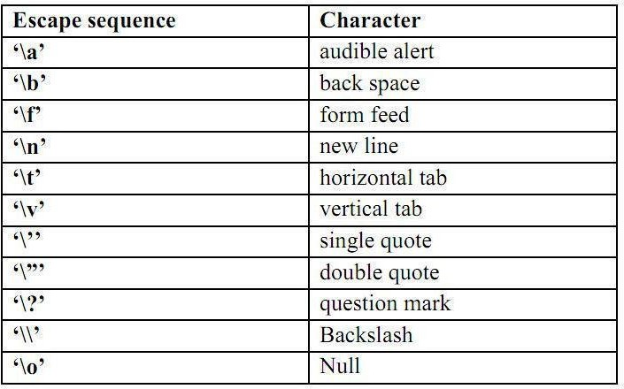
OPERATORS AND EXPRESSIONS
An operator is a symbol which represents a particular operation that can be performed on data. An operand is the object on which an operation is performed.
By combining the operators and operands we form an expression. An expression is a sequence of operands and operators that reduces to a single value.

C operators can be classified as
  - Arithmetic operators
  - Relational operators
  - Logical operators
  - Assignment operators
  - Increment or Decrement operators
  - Conditional operator
  - Bit wise operators
  - unary operator
  - Special operators 10.Additional operators in c++
- ARITHMETIC OPERATORS : All basic arithmetic operators are present in C. operator meaning
+ add
- subtract
* multiplication

/ division
% modulo division(remainder)
An arithmetic operation involving only real operands(or integer operands) is called real arithmetic(or integer arithmetic). If a combination of arithmetic and real is called mixed mode arithmetic.
/*C program on Integer Arithmetic Expressions*/
#include<iostraem.h> void main()
{
int a, b;
cout<"Enter any two integers"; cin>>a>>b;
cout<<"a+b"<< a+b; cout<<"a-b"<< a-b; cout<<"a*b"<< a*b; cout<<"a/b"<< a/b; cout<<"a%b"<< a%b;
}

OUTPUT:
a+b=23 a-b=17 a*b=60 a/b=6 a% b=2

- RELATIONAL OPERATORS : We often compare two quantities and depending on their relation take certain decisions for that comparison we use relational operators.
operator meaning

< is less than
> is greater than
<= is less than or equal to
>= is greater than or equal to
== is equal to
!= is not equal to
/* C program on relational operators*/
#include<iostream.h> void main()
{
int a,b; clrscr();
cout<<"Enter a, b values:"; cin>>a>>b; cout<<"a>b"<< a>b; cout<<"a>=b"<< a>=b; cout<<"a<b"<< a<b; cout<<"a<=b"<< a<=b; cout<<"a==b"<< a==b; cout<<"a!=b"<< a!=b;
} OUTPUT:
Enter a, b values: 5 9
a>b: 0 //false
a<b: 1 //true
a>=a: 1 //true
a<=b: 1 //true
a==b: 0 //false
a!=b: 1 //true
- LOGICAL OPERATORS:
Logical Data: A piece of data is called logical if it conveys the idea of true or false. In C++ we use int data type to represent logical data. If the data value is zero, it is considered as false. If it is non -zero (1 or any integer other than 0) it is considered as true. C++ has three logical operators for combining logical values and creating new logical values:
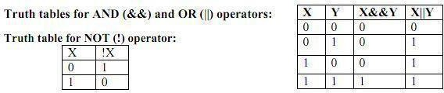
Note:Below program works in compiler that support C99 standards
#include<iostream.h> #include<stdbool.h> int main()
{
bool a,b;
/*logical and*/
a=0;b=0;
cout<<" a&&b "<< a&&b<<endl;
a=0;b=1;
cout<<" a&&b "<< a&&b<<endl;
a=1;b=0;
cout<<" a&&b "<< a&&b<<endl;
a=1;b=1;
cout<<" a&&b "<< a&&b<<endl;
/*logical or*/
a=0;b=0;
cout<<" a||b "<< a||b<<endl;
a=0;b=1;
cout<<" a||b "<< a||b<<endl;
a=1;b=0;
cout<<" a||b "<< a||b<<endl;
a=1;b=1;
cout<<" a||b "<< a||b<<endl;
/*logical not*/
a=0;
cout<<" a||b "<< a||b<<endl;
a=1;
cout<<" a||b "<< a||b<<endl;
return 0;
} OUTPUT:
0&&0=0
0&&1=0
1&&0=0
1&&1=1
0||0=0
0||1=1

1||0=1
1||1=1
!0 =1
!1 =0

ASSIGNMENT OPERATOR:
The assignment expression evaluates the operand on the right side of the operator (=) and places its value in the variable on the left.
Note: The left operand in an assignment expression must be a single variable. There are two forms of assignment:
- Simple assignment
- Compound assignment
Simple assignment :
In algebraic expressions we found these expressions. Ex: a=5; a=a+1; a=b+1;
Here, the left side operand must be a variable but not a constant. The left side variable must be able to receive a value of the expression. If the left operand cannot receive a value and we assign one to it, we get a compile error.
Compound Assignment:
A compound assignment is a shorthand notation for a simple assignment. It requires that the left operand be repeated as a part of the right expression. Syntax: variable operator+=value

Ex:
A+=1; it is equivalent to A=A+1;

Advantages of using shorthand assignment operator:
- What appears on the left-hand side need not be repeated and therefore it becomes easier to write.
- The statement is more concise and easier to read.
- The statement is more efficient.
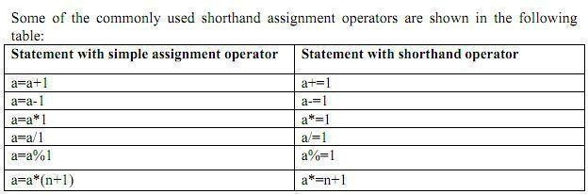

5.INCREMENT (++) AND DECREMENT (--) OPERATORS:
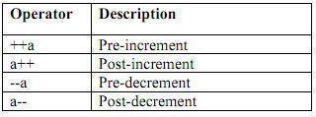
The operator ++ adds one to its operand where as the operator - - subtracts one from its operand. These operators are unary operators and take the following form:

Both the increment and decrement operators may either precede or follow the operand.
Postfix Increment/Decrement :( a++/a--)
In postfix increment (Decrement) the value is incremented (decremented) by one. Thus the a++ has the same effect as

a=a+1; a--has the same effect as a=a-1.
The difference between a++ and a+1 is, if ++ is after the operand, the increment takes place after the expression is evaluated.
The operand in a postfix expression must be a variable. Ex1:
int a=5;
B=a++; Here the value of B is 5. the value of a is 6. Ex2:
int x=4; y=x--; Here the value of y is 4, x value is 3 Prefix Increment/Decrement (++a/ --a)
In prefix increment (decrement) the effect takes place before the expression that contains the operator is evaluated. It is the reverse of the postfix operation. ++a has the same effect as a=a+1.
--a has the same effect as a=a-1. Ex: int b=4;
A= ++b;
In this case the value of b would be 5 and A would be 5.
The effects of both postfix and prefix increment is the same: the variable is incremented by
1. But they behave differently when they used in expressions as shown above. The execution of these operators is fast when compared to the equivalent assignment statement.

#include<iostream.h> int main()
{
int a=1; int b=5;
++a;
cout<<"a="<<a<<endl;
--b;
cout<<"b="<<b<<endl; cout<<"a="<<a++<<endl; cout<<"a="<<a<<endl; cout<<"b="<<b--<<endl; cout<<"b="<<b<<endl; return 0;
}
a=2 b=4 a=2 a=3 b=4 b=3
- CONDITIONAL OPERATOR OR TERNARY OPERATOR:

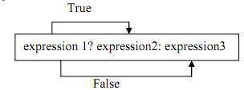
A ternary operator requires two operands to operate Syntax:

#include<iostream.h> void main()
{
int a, b,c;
cout<<"Enter a and b values:"; cin>>a>>b;

c=a>b?a:b;
cout<<"largest of a and b is "<<c;
}
Enter a and b values:1 5 largest of a and b is 5
- BIT WISE OPERATORS : C supports special operators known as bit wise operators for manipulation of data at bit level. They are not applied to float or double.
operator meaning
& Bitwise AND

^ Bitwise exclusive OR
<< left shift
>> right shift
~ one's complement
Bitwise AND operator (&)
The bitwise AND operator is a binary operator it requires two integral operands (character or integer). It does a bitwise comparison as shown below:
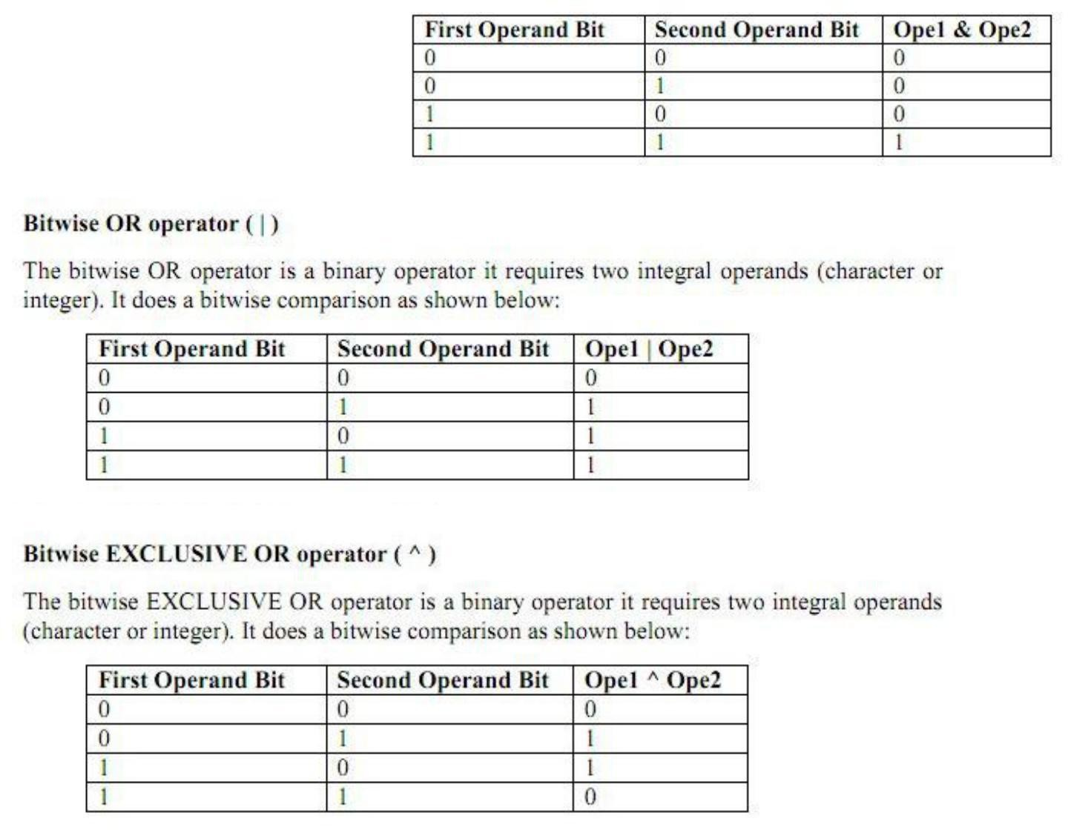
Shift Operators
The shift operators move bits to the right or the left. These are of two types:
. •Bitwise shift right operator
. •Bitwise shift left operator

Bitwise shift right operator
It is a binary operator it requires two integral operands. The first operand is the value to be shifted and the second operand specifies the number of bits to be shifted. When bits are shifted to right,the bits at the right most end are deleted and a zero is inserted at the MSB bit.
#include<iostream.h>
void main()
{
int x,shift;
cout<<”Enter a number:”); cin>>x;
cout<<”enter now many times to right shift: “; cin>>shift;
cout<<”Before Right Shift:”<<x;
x=x>>shift;
cout<<”After right shift:”<<x;
}
Run1:
Enter a number:8
enter now many times to right shift:1 Before Right Shift:8
After right shift:4

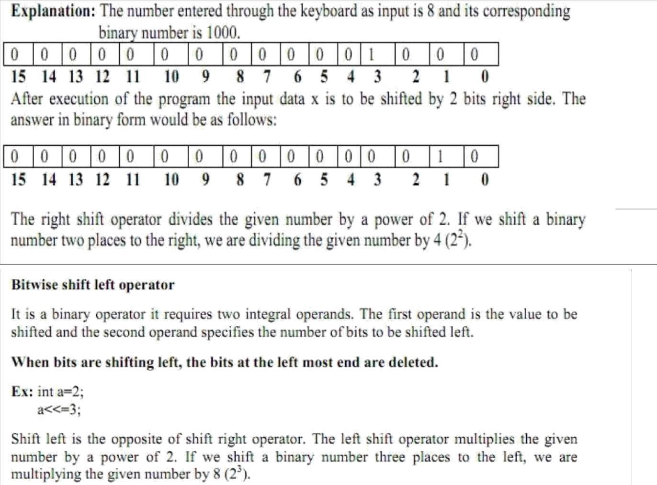

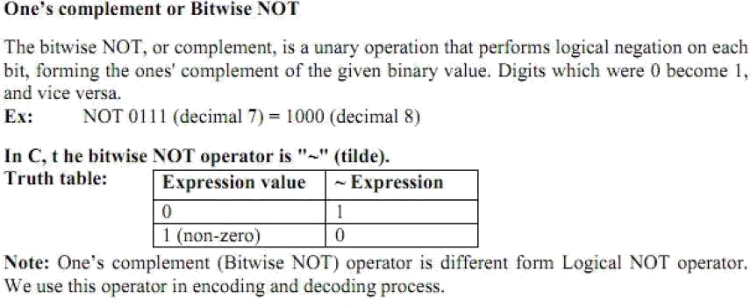
- SPECIAL OPERATORS
These operators which do not fit in any of the above classification are ,(comma), sizeof, Pointer operators(& and *) and member selection operators (. and ->). The comma operator is used to link related expressions together.
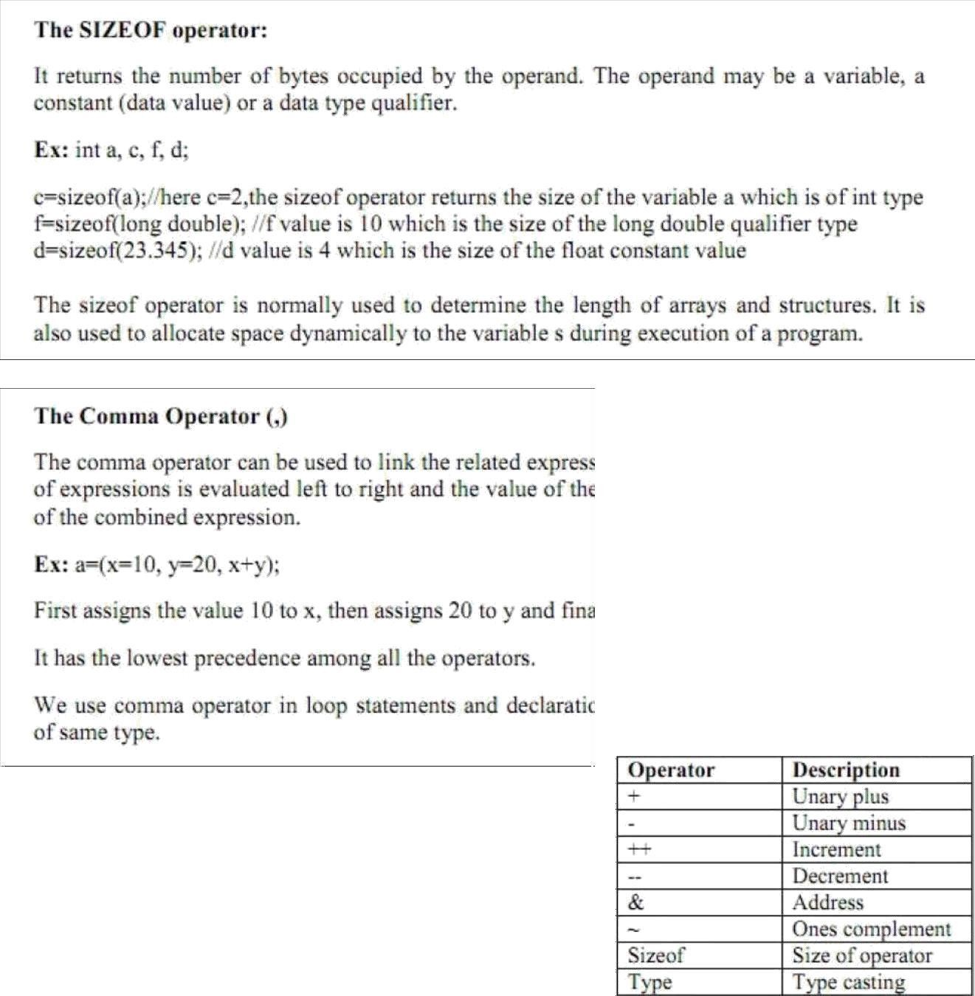

9.UNARY OPERATOR: operator which operates on single operand is called unary operator

Operators in c++: All above operators of c language are also valid in c++.New operators introduced in c++ are

Sno | Operator | Symbol
1. | Scope resolution operator | ::
2. | Pointer to a member declarator | ::*
3. | Pointer to member operator | ->*,->
4. | Pointer to member operator | .*
5. | new | Memory allocating operator
6. | delete | Memory release operator
7. | endl | Line feed operator
8. | setw | Field width operator
9. | insertion | <<
10. | Extraction | >>

Scope Resolution operator:
Scope:-Visibility or availability of a variable in a program is called as scope. There are two types of scope.
i)Local scope ii)Global scope
Local scope: visibility of a variable is local to the function in which it is declared.
Global scope: visibility of a variable to all functions of a program Scope resolution operator in “::” .
This is used to access global variables if same variables are declared as local and global PROGRAM1.2:-
#include<iostream.h> int a=5;
void main()
{
int a=10;
cout<<”Local a=”<<a<<endl; cout<<”Global a=”<<::a<<endl;
}
Expected output:
Local a=10 Global a=5
Member Dereferencing operator:-
1. | Pointer to a member declarator | ::*
2. | Pointer to member operator | ->*,->
3. | Pointer to member operator | .*

Pointer to a member declarator ::*
This operator is used for declaring a pointer to the member of the class #include<iostream.h>
class sample
{public:
int x;
};
int main()
{ sample s; //object
int sample ::*p;//pointer decleration s.*p=10; //correct
cout<<s.*p;
}
Output:10

Pointer to member operator ->*
#include<iostream.h> class sample
{
public:
int x;
void display()
{
cout<<"x="<<x<<endl;
}
};
int main()
{

sample s;
sample *ptr;
//object

int sample::*f=&sample::x; s.x=10;
ptr=&s; cout<<ptr->*f; ptr->display();
}

Pointer to member operator .*
#include<iostream.h> class sample
{

public:

};

int x;

int main()
{
sample s; //object
int sample ::*p;//pointer decleration s.*p=10; //correct
cout<<s.*p;
}

Manipulators:
Manipulators are the operators used to format the data that is to be displayed on screen.The most commonly
used manipulators are endl and setw
endl:-it is used in output statement and inserts a line feed. It is similar to new line character (“\n”) ex:
………………..

cout<<”a=2”<<endl; cout<”name=sunil”<<endl;
……………….

Output: a=2 name=sunil setw:-
this manipulator allows a specified width for a field that is to be printed on screen
and by default the value printed is right justified.This function is available in header file iomanip.h
#include<iostream.h> #include<iomanip.h> using namespace std; int main()
{
int s=123; cout<<"s="<<setw(10)<<s ;
}
output
s= 123
Insertion (<<) and Extraction (>>) operators:
the operators are use with output and input objects ex:
cout<<”Enter n”; cin>>n

